QA Session 1 results:

# Common/Biggest complaint:

The jumping feels off and coupled with the lack of respawns the level becomes extremely frustrating**. All players mentioned this**.

*“Even if the controls are bad on purpose you need to be aware that players will just stop playing and won't reach the nice looking levels with good controls”*

# Devnotes:

1) Everyone understood they’re written by the devs of the game

“Good job with the russian ))))”

2) Everyone read the notes, one person said they could be more fun.

3)

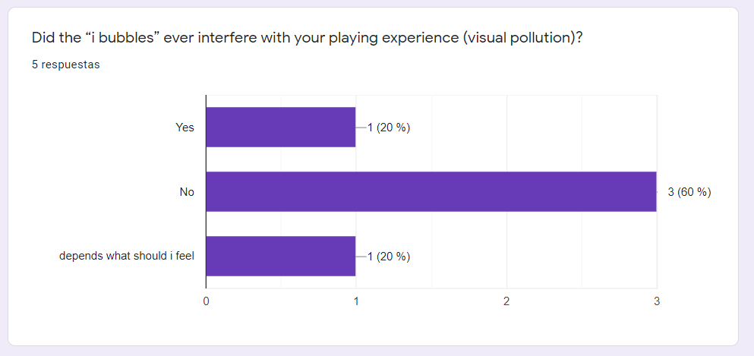

4) The Characters felt distinct.

A common suggestion was making their comments look different depending on the character (by changing the color, shape of the note and/or font)

Two Players theorized the characters and their personalities were a reflection of us.

5) Clumped Devnotes are specifically hard to open (I think we need to lower the look-at sensitivity)

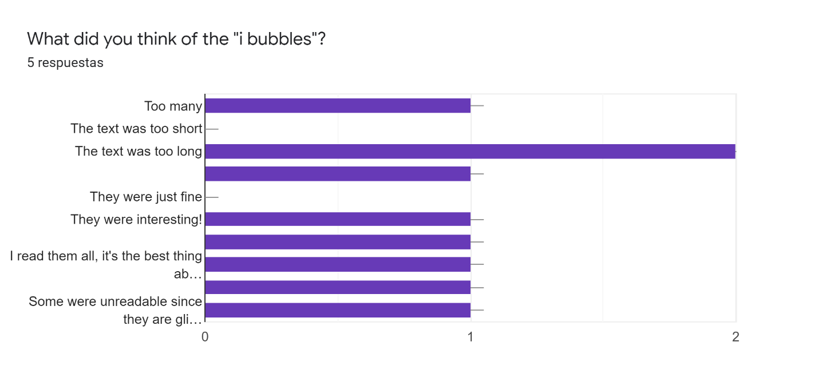

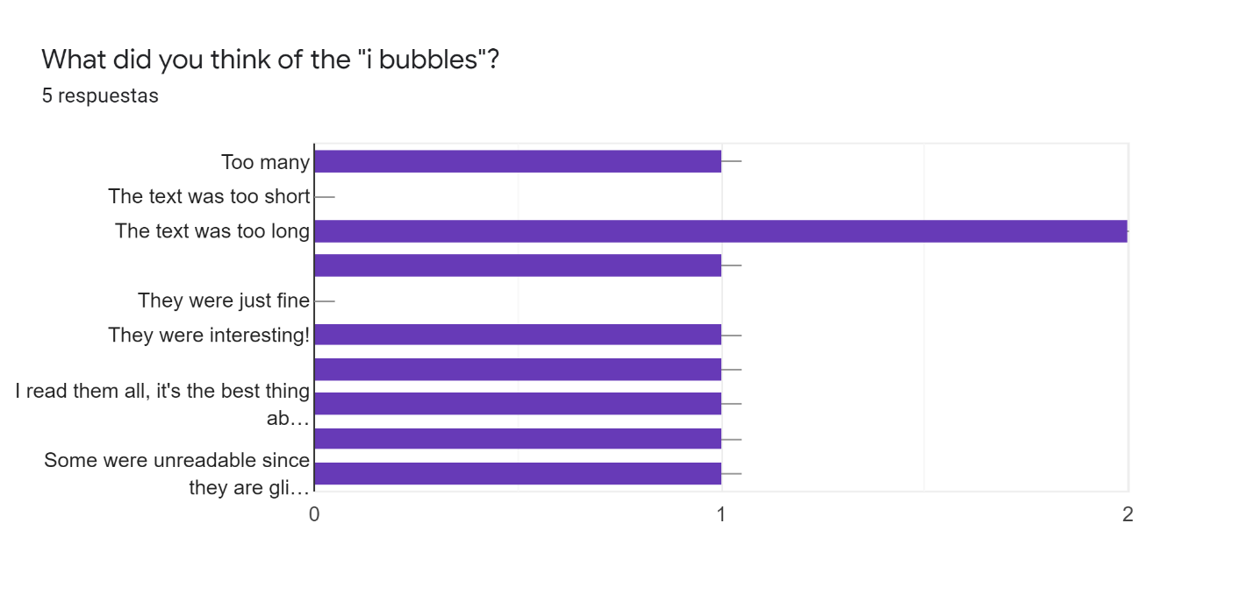

**Custom Answers:**

“They were one of the most interesting aspects of the game! But sometimes they felt a bit less interesting, like fillers somehow. I'm not sure if it was a problem of the bubbles, or just the level itself felt long.”

“Some were unreadable since they are glitching through the walls. Some were not loading even as I walk right in front of them.”

“The number was good, but I think I started paying attention less as time went on, but that's normal”

“I read them all, it's the best thing about the game, following along. They were sometimes cut off by the level geometry or turned the wrong way though”

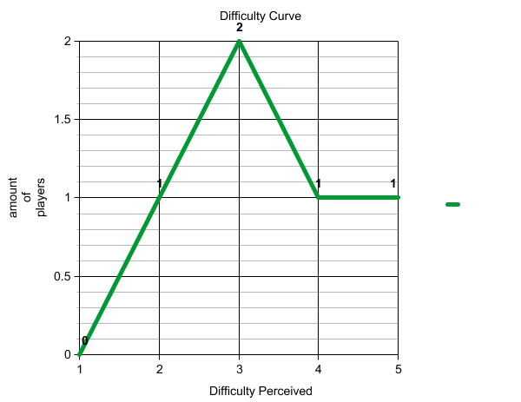

# Enemies

1)The players understood they were enemies pretty quickly, when the enemy shot however was very unclear **we should fix this.**

Suggestions for improving their recognition as enemies were: Giving them angry eyes, giving them a red outline, and adding a Devnote next to a defunct one (as introduction).

# Stage 1 Level Layout

One player complained about the level being too big in that it made you be “going somewhere with nothing to do”

# General

Half of the players seemed to notice that the second level is an evolution of the first stage

Do the levels convey a sense of progression?

**Yes…**

but for me mostly from the text rather then the layout I'd say

until the massive backtracking haha

Falling into the concept art platforms was interesting, but I wasn't sure at first if that is how it was meant to be. Maybe players get used to this kind of "weirdness" after seeing them a couple of times.

# Stage 2 Mood:

*“Definitely a contrast to the first level - the bridge and the columns in the second building made it feel more concrete and fleshed out than the blockier first level”*

*“Feels like a museum. Also looks like it would be really fun on a scooter or a scateboard or something, my random thoughts that have nothing to do with anything.”*

*“Looks pretty cool. Some hallways were really long though, but that's probably my fault for not realizing that there was the shift button.”*

*“Seemed quite ominous. It gave the vibes of an ancient temple”*

# Stage 2 Layout:

*“It seemed to have a lot of branching paths in the beginning, but it didn't feel rewarding to pursue them. I'm wondering now if the bow was in one of those paths...”*

The layout is legible.

# Comments for us:

“I think you guys are on a good track there, nice job! I have the feeling the main problem is that the experience feels a bit lost between the narrative part coming from the devs and the gameplay-focused sessions. It's a bit of a "I'm still unsure what this game that I'm playing is trying to be". Though this feeling might be from the platforming not being that great, summed with the respawn being pretty unforgiving. I wish the i bubble logs would be explored more as part of the gameplay (the logs saying that there will be an enemy right after the walls, or comments on how they wanted to adjust gravity etc.). I'm curious if you'll try to evolve a narrative using the relationship between the devs. I almost wish you wouldn't, so the focus would be on the evolution of the game indeed, but I can see it also as a unique storytelling tool haha I feel like this connection between the devs and the player was the most interesting thing of the game. Seeing what they intended things to be, and shortly after seeing those things there was really cool. It's similar to seeing a theather play before and after full set up. If that's what you're intending, maybe making those loops shorter might enhance the entire experience (for example adding smaller levels before can be interesting, like a closed room used to tweek movement with a few concept arts around and some i bubble with devs discussions, etc). Overall, it's a pretty cool idea! I think once elements are more figured out to support the direction you want to go, it will be pretty cool. I'm looking forward to the next iteration and to the decisions you make!”

“Just mainly the jumping so far and the chat bubbles. Kinda hard to read through long texts, I kinda found myself loosing interest in reading them after a while. Maybe in the later levels where the world would be more polished, maybe add a voice over to them, maybe even have them as voice recordings instead of text reading like those Fallout tapes you find or those Bioshock recordings. Or if this is not possible, maybe just reduce the text. Or have this bubbles as sheets of glowing paper lying around that the player can pick-up, then zooms into the camera when they read it. Maybe have a different font for different people? Maybe different kind of sheets of paper for different persons? Maybe tiny post-its for the casual artist guy and a full sheet of paper for serious Sandra? Idk”

“Cool concept and I like how the characters banter and develop. As you may have guessed I disliked the backtracking and punishing resets since I don't feel they add anything of value to the experience at this point”